# E-Receipt System

1. Login

Website：<http://app/ers/>

Login name/password：manage by admin

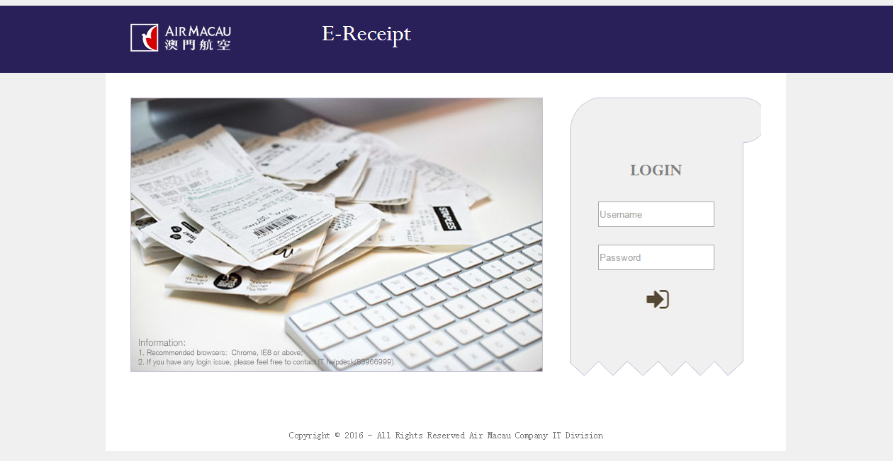

1. Admin setting

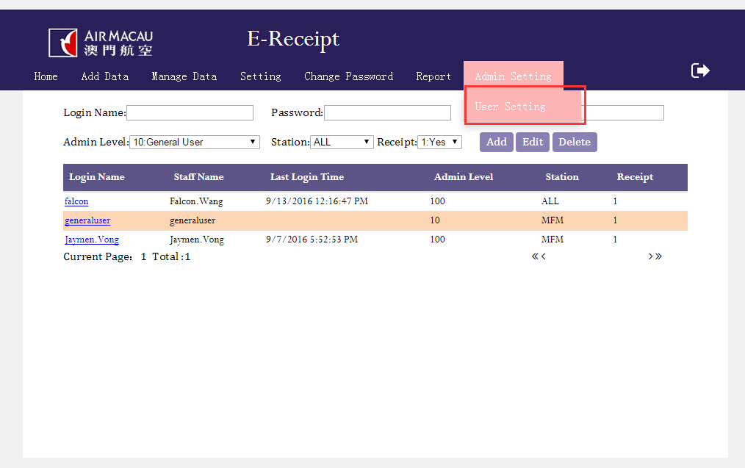

* 1. Admin Level

General user can access to change password

Reporter can access to report

Superuser can access to Settings

System administrator can access to admin settings

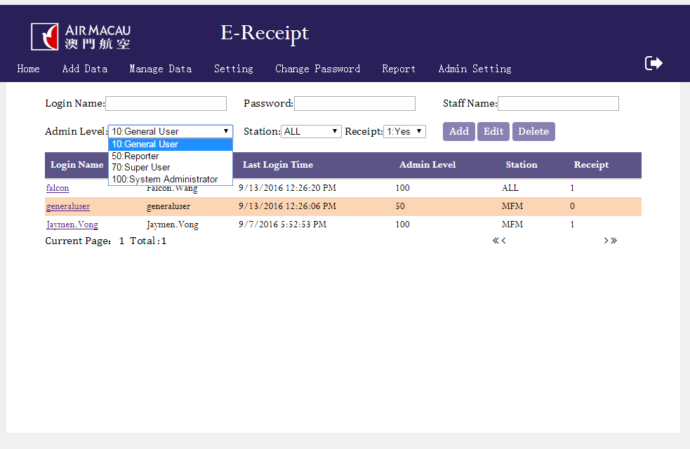

* 1. Station

Station setting is for permission control the user can view and add receipt

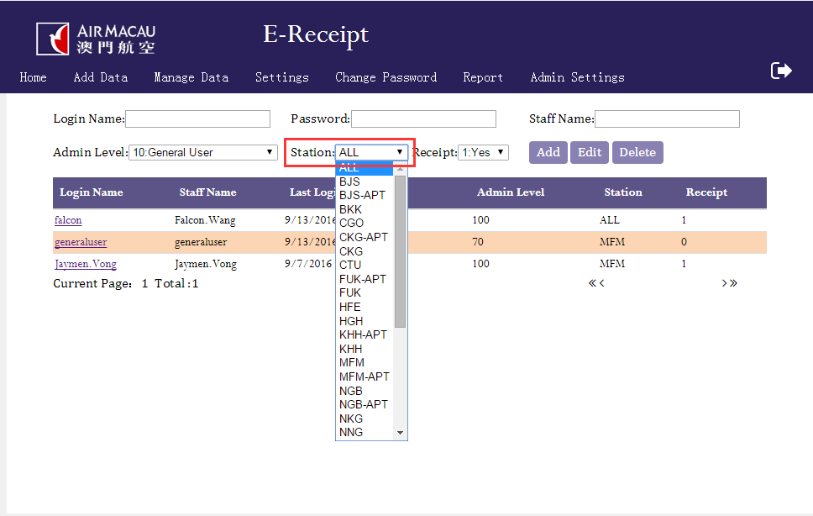

* 1. Add a new user

Fill in the information and select the permission ,then click add button

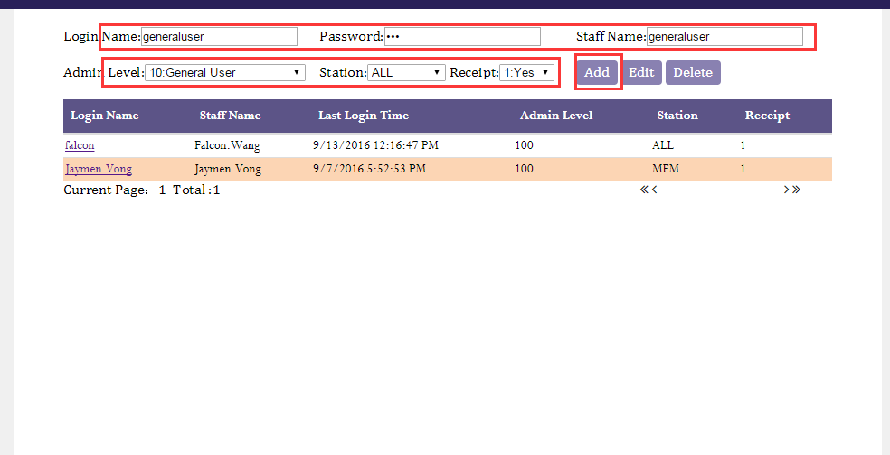

* 1. Edit user/ Delete user
     1. Select the user
     2. Edit the information then click edit/ click delete

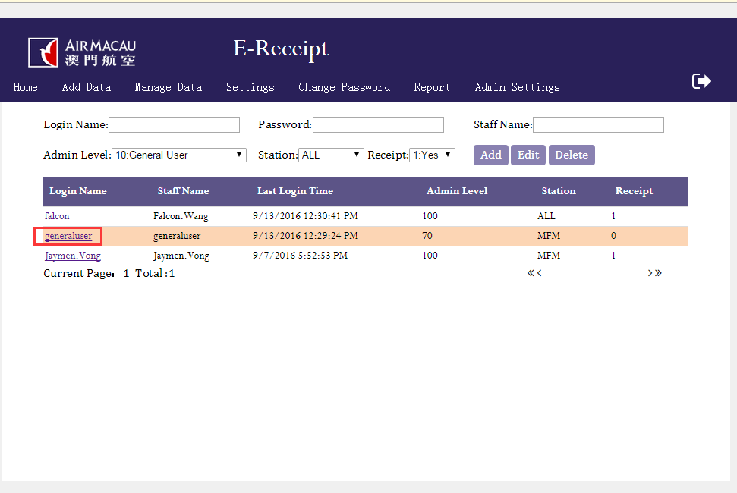 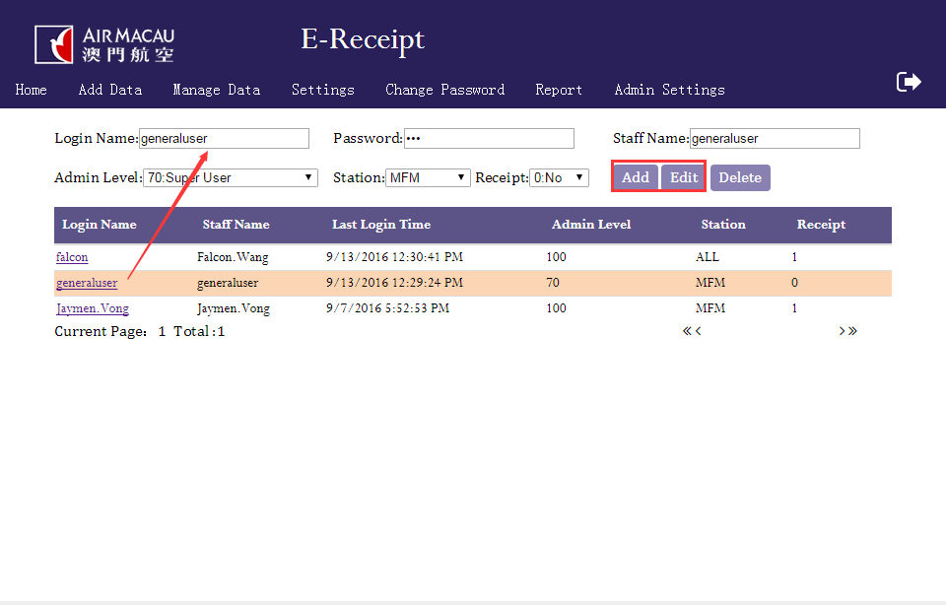

1. Settings

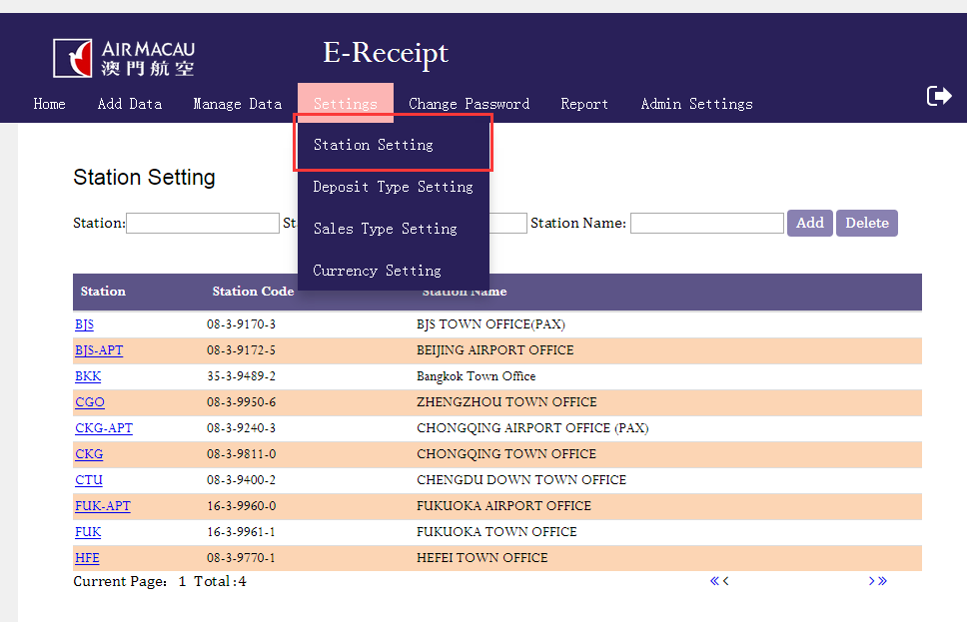

* 1. Add new setting
     1. Fill in the information and the order
     2. 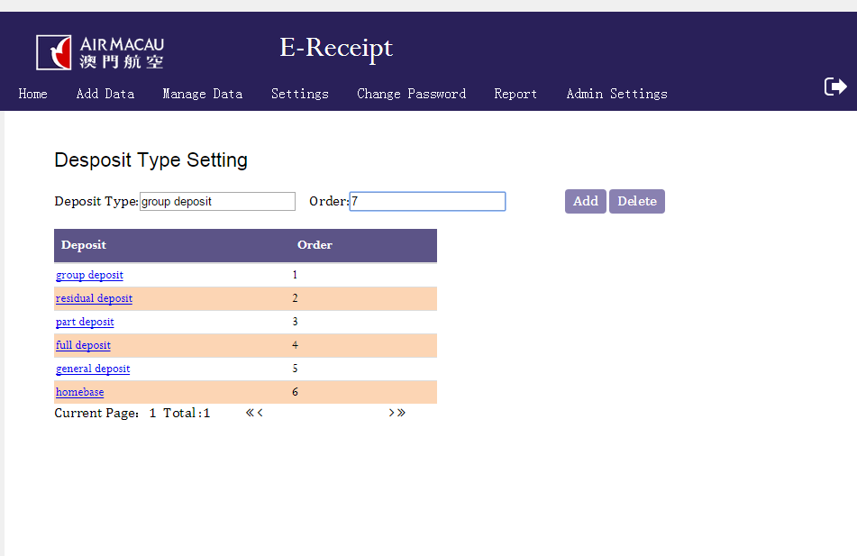
  2. Delete
     1. Select the item and click delete
     2. 

1. Add new Data

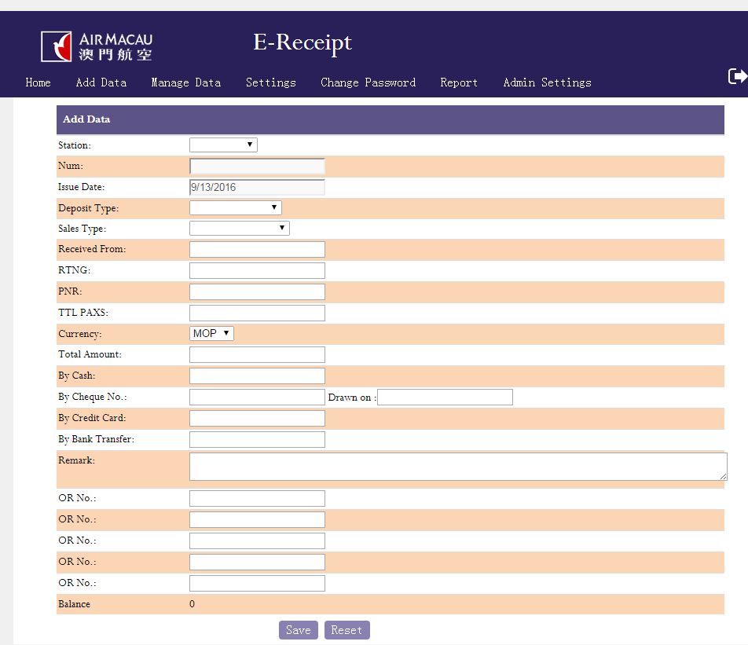

1. Manage Data

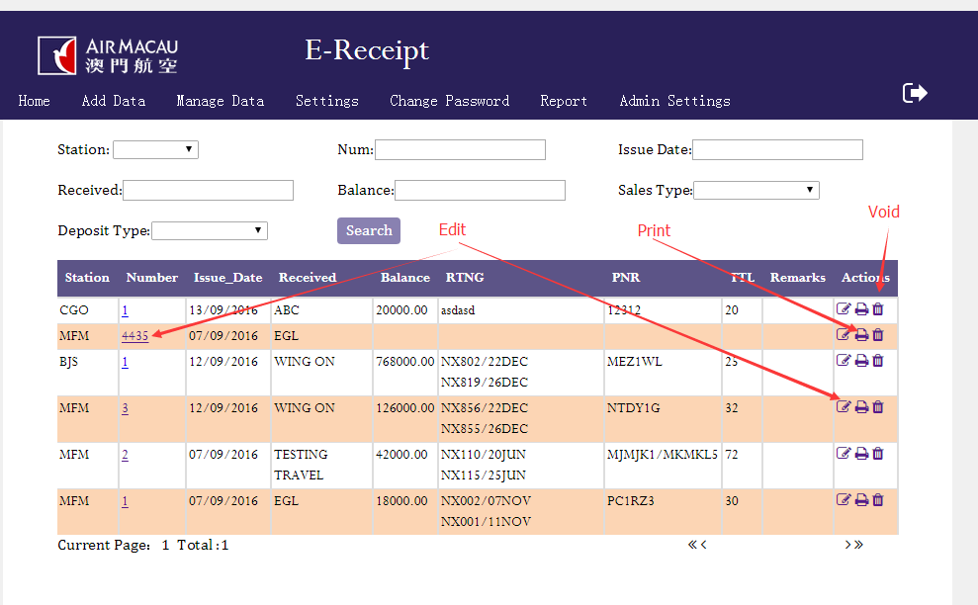

1. Edit

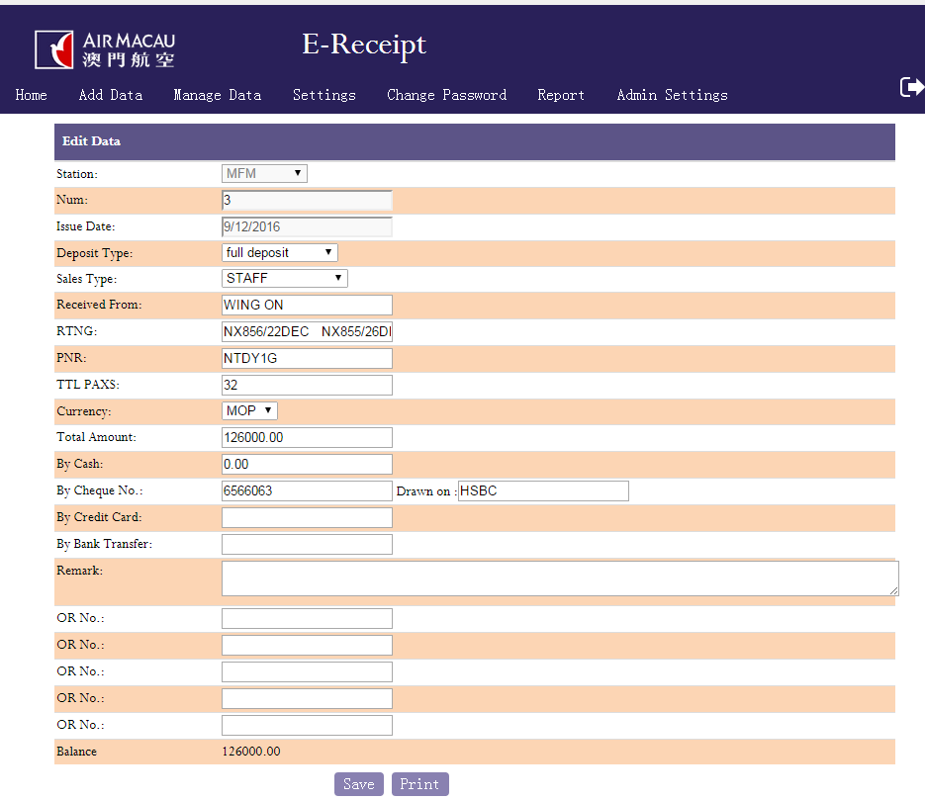

1. Print

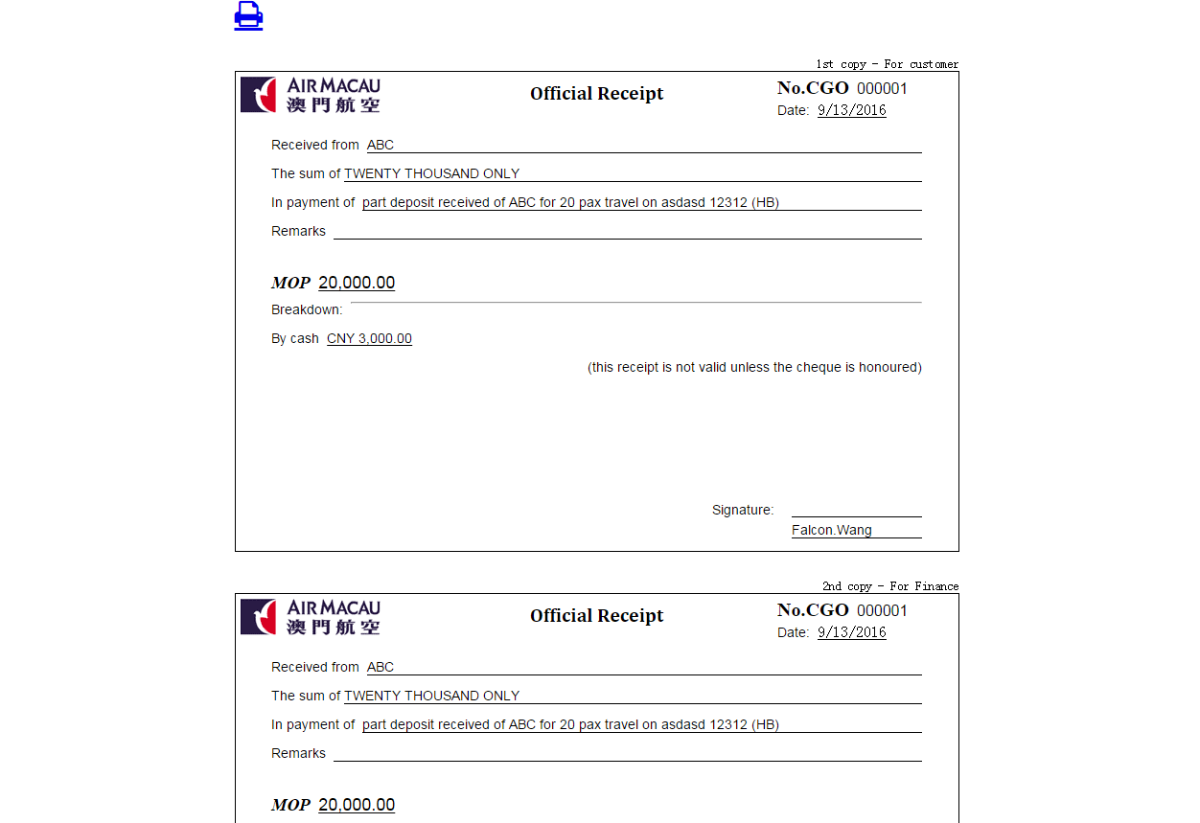

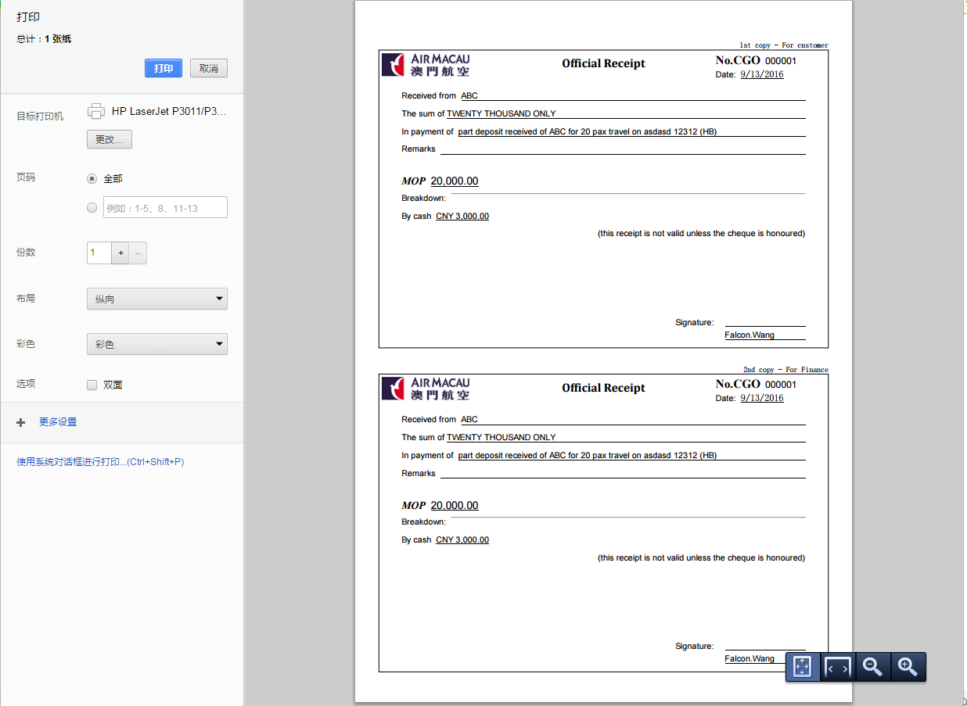

1. Report

